1. Remove McAfee and McAfee Agent services

Add/Remove > Program >Uninstall

Command Prompt Removal: C:\Program Files (x86)\mcafee\Common Framework\frminst.exe /forceuninstall

Reboot Required.

1. Remove McAfee traces if any under Non-Plug and Play Drivers > hidden devices in Device Manager:

At a command prompt, type the following command , and then press ENTER:

set devmgr_show_nonpresent_devices=1

Type the following command a command prompt, and then press ENTER:

start devmgmt.msc

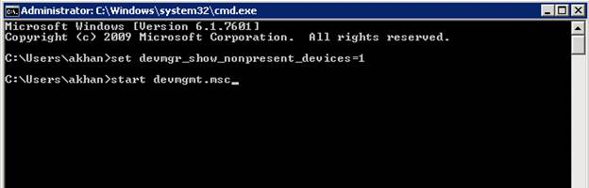

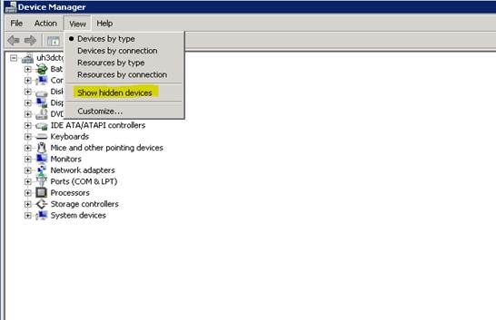

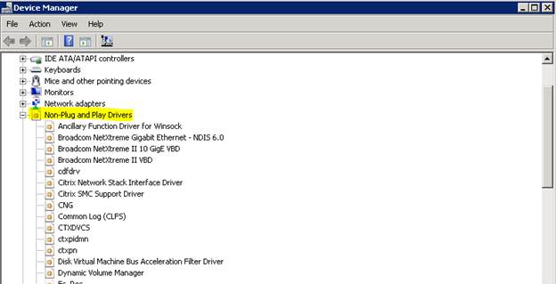

Click on All McAfee and Un-Install, multiple reboots may be required.

